[www.example.com](http://www.example.com)

The screenshot is as follows:

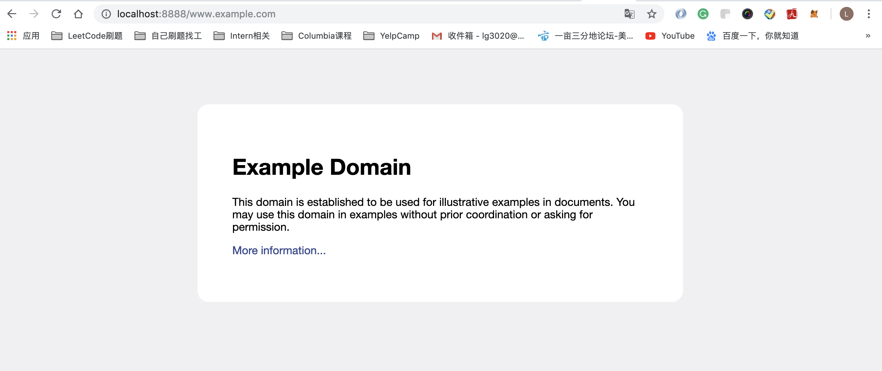

The cache file is in this directory



[www.google.com](http://www.google.com)

The screenshot is as follows:

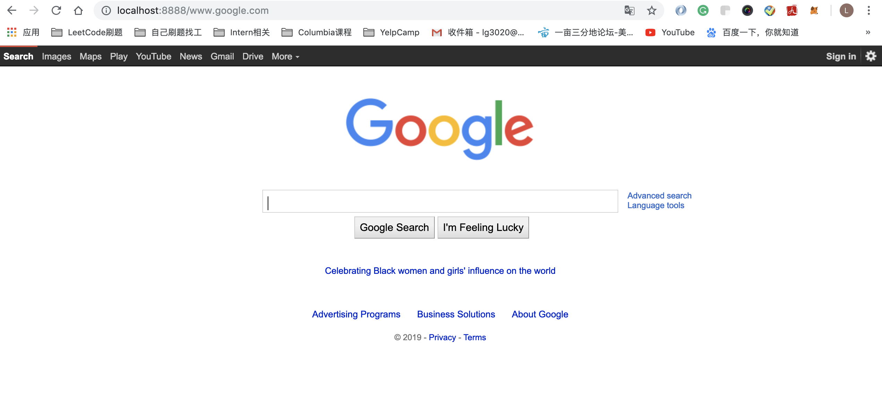

The cache file is in this directory



[www.espn.com](http://www.espn.com)

The screenshot is as follows:

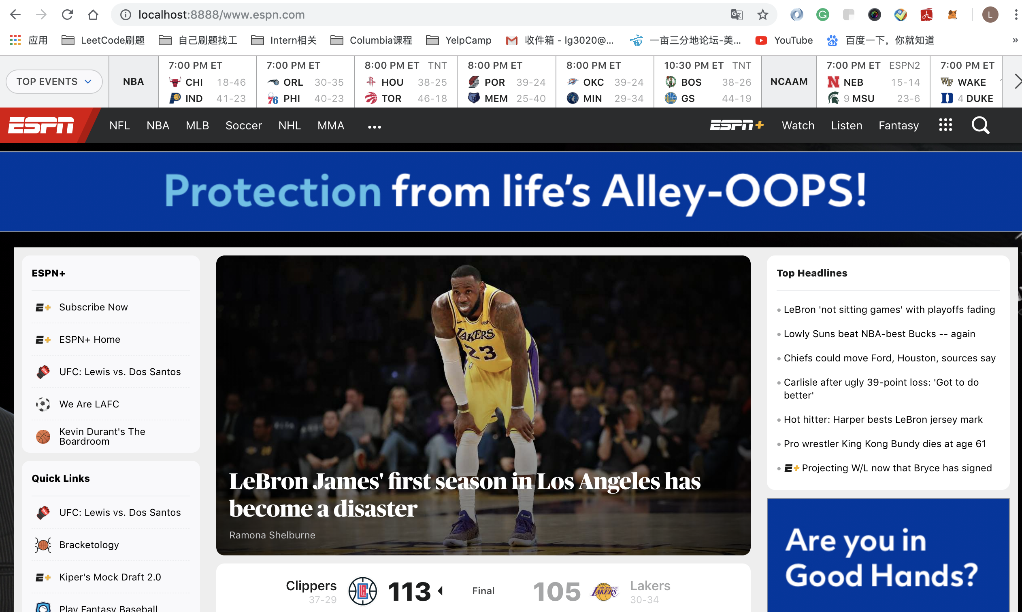

The cache file is in this directory



[www.sina.com](http://www.sina.com)

The screenshot is as follows:

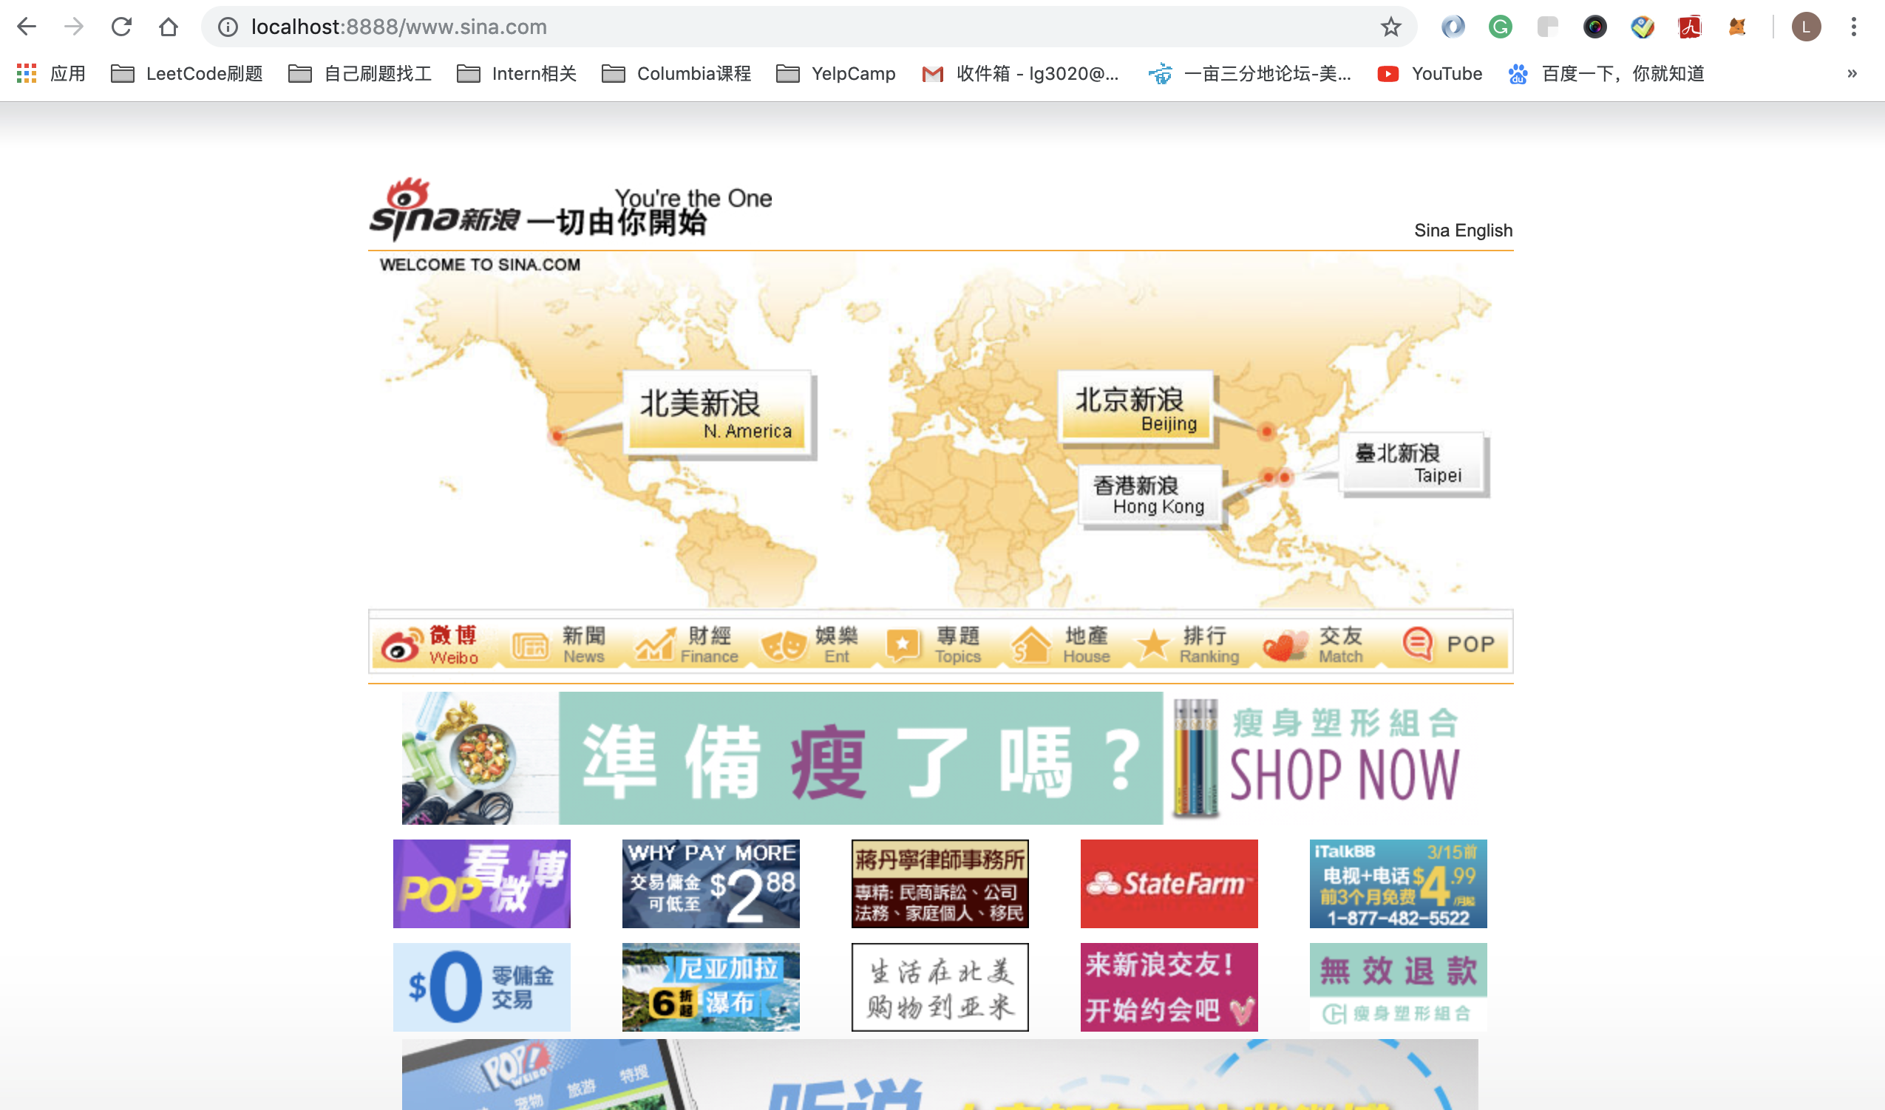

The cache file is in this directory



[www.cqu.edu.cn](http://www.cqu.edu.cn)

The screenshot is as follows:

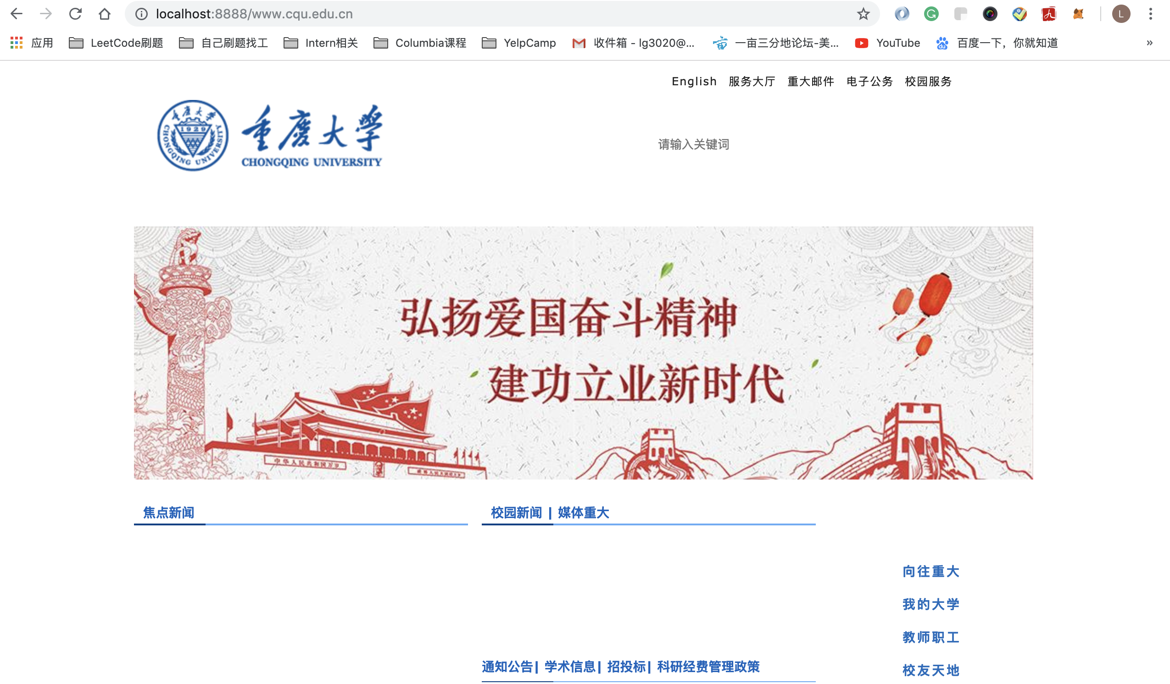

The cache file is in this directory

